Multi-Branch Business Performance Analysis

By:
Sai lokesh meela

CONTENTS

S. No |  | Page No
1 | EXECUTIVE SUMMARY | 3
2 | PROBLEM DESCRIPTION | 4
3 | ABOUT DATASET | 6
4 | DATA CLEANING & PREPROCESSING | 6
5 | EXPLORATORY DATA ANALYSIS | 7
6 | POWER BI DASHBOARD | 9
7 | FINDINGS & RECOMMENDATIONS | 10
8 | CONCLUSIONS | 11
9 | INDIVIDUAL CONTRIBUTIONS | 12
10 | REFERENCES | 13
11 | APPENDIX | 13

EXECUTIVE SUMMARY

Problem:
Retail businesses struggle to analyze and explain sales performance variations across branches and channels (physical stores and online). The reliance on multi-channel strategies necessitates comprehensive data analysis to derive actionable insights for optimizing revenue and operations.

Data:
The datasets used in this analysis include:
- Orders.csv: Details customer orders, including order mode, location, and customer details.
- Details.csv: Information about products, payment methods, revenue, and profit for each order. The dataset covers 1500 rows of data from 21 states in India.

Approach:
- Data Preprocessing: Ensured data quality with no missing or duplicate values. Created new metrics like Average Order Value (AOV).
- Exploratory Data Analysis (EDA): Used Python libraries to uncover trends, such as:
- Online purchases dominate over in-store purchases.
- States with better telecommunication infrastructure show higher online sales.
- Furniture generates high profit variance, while clothing leads in sales quantity.
- Visualization: Developed an interactive Tableau dashboard with filters for granular analysis (e.g., by quarter, state, and category).

Key Findings:
- Top Performing States: Maharashtra and Madhya Pradesh lead in revenue, indicating population size as a key driver.
- Category Insights: Clothing dominates sales, while furniture offers high profit margins despite lower sales.
- Payment Modes: Credit card and EMI payments generate high revenue but pose significant financial risks.
- Sub-Category Performance: High-margin items like printers and bookcases outperform other sub-categories.

Recommendations:
- Regional Focus: Target marketing efforts in Maharashtra and Madhya Pradesh to maximize returns.
- Product Strategy: Expand clothing options and improve online sales infrastructure.
- Payment Strategy: Encourage digital payment methods while managing risks associated with EMI and credit card transactions.
- Inventory Management: Optimize supply for high-demand categories and reduce losses in underperforming ones (e.g., electronic games).

Benefits:
The project enables businesses to:
- Allocate resources effectively.
- Align marketing campaigns with high-performing products and regions.
- Forecast demand and manage inventory using seasonal trends.
- Enhance customer experience by addressing regional preferences.
- Maximize profitability by focusing on high-margin products.

Outcomes of this project:
The dashboard provides actionable insights for strategic decision-making, offering clear metrics for revenue, profit, and performance trends across locations and categories.

PROBLEM DESCRIPTION

Businesses face significant challenges in analyzing sales performance variations across different branches and sales channels (physical stores and online). Despite the availability of large datasets, deriving actionable insights remains difficult. Variations arise from factors like market conditions, customer preferences, competition, and regional demographics. Without addressing these discrepancies, businesses risk inefficiencies in revenue optimization, inventory management, and customer engagement strategies.

Importance of Addressing the Problem:
- Multi-channel retail strategies rely on balanced performance across physical and online channels to maximize profits.
- Understanding regional and channel-specific sales trends can lead to more targeted marketing and operational improvements.
- Efficient inventory allocation and customer engagement depend on identifying key drivers of sales performance.

Motivation for Addressing the Problem
This project is motivated by the need to leverage advanced data analytics to help businesses:
- Interpret their data more effectively.
- Improve decision-making through actionable insights.
- Build competitive advantages by aligning resources with performance trends.

Chosen Approach
To address the problem, the following structured approach is used:

- Data Integration: Combined datasets (sales, operational metrics) from physical and online channels for comprehensive analysis.
- Exploratory Data Analysis (EDA): Used Python libraries to uncover trends and relationships in sales data.
- Data Visualization: Develop an interactive Power BI dashboard to display performance metrics and trends in an easily interpretable manner.
- Actionable Insights: Generate recommendations for targeted marketing, optimized inventory, and improved customer experience based on findings.

Proposed Solution
The project aims to create a visualized, data-driven decision-making tool that:
- Highlights sales trends and performance drivers.
- Provides a granular analysis of key metrics (e.g., revenue, profit) across regions and product categories.
- Suggests actionable strategies for enhancing revenue and operational efficiency.

Potential Outcomes and Goals

The project is expected to yield the following outcomes:
- Identification of high-performing regions and sales channels.
- Insights into customer behavior, product preferences, and seasonal trends.
- Targeted recommendations for marketing strategies and inventory allocation.
- A user-friendly dashboard to support data-driven business decisions.

Significance and Contribution

The project contributes to existing knowledge by:
- Demonstrating the use of analytics and visualization in multi-channel retail analysis.
- Providing a reusable framework for businesses facing similar challenges.
- Offering insights at the intersection of retail strategy, customer engagement, and data science.
- Insights to business & stakeholders

How the outcome helps business & stakeholders

- Enable businesses to allocate resources more effectively
- Help marketing teams optimize campaigns based on regional and category-specific trends.
- Allow inventory managers to forecast demand and reduce waste.
- Improve overall customer satisfaction by addressing channel-specific needs.
- By bridging the gap between raw data and actionable insights, this project helps stakeholders to enhance their strategic decision-making and operational efficiency.

ABOUT DATASET

Data is obtained from a public source. It has 2 datasets - ‘Orders’ and ‘Details’ in csv format. The Orders.csv file contains transactional details of customer orders, including order modes (e.g., online or in-store) and regional information. The Details.csv file contains product-level details for each order, such as category, payment method, amount, and profit.

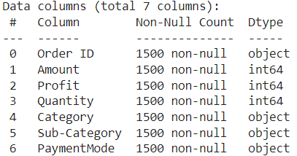 | 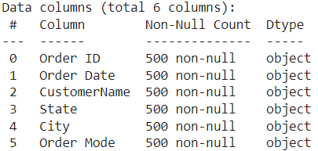
Fig.1(a) Info of Details.csv | Fig. 1(b) Info of Orders.csv

Orders.csv contains 500 rows of data, Details.csv contains about 1500 rows of data. Fig.1(a), Fig. 1(b) shows the attributes info from each dataset.

DATA CLEANING & PREPROCESSING

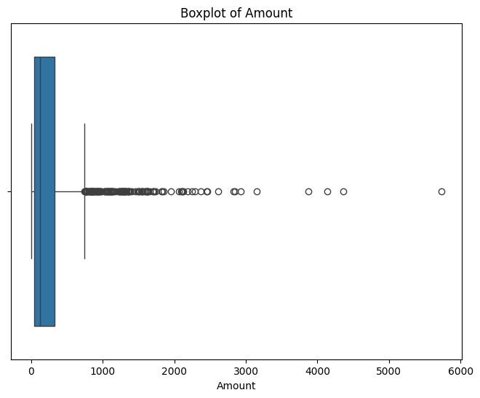 | 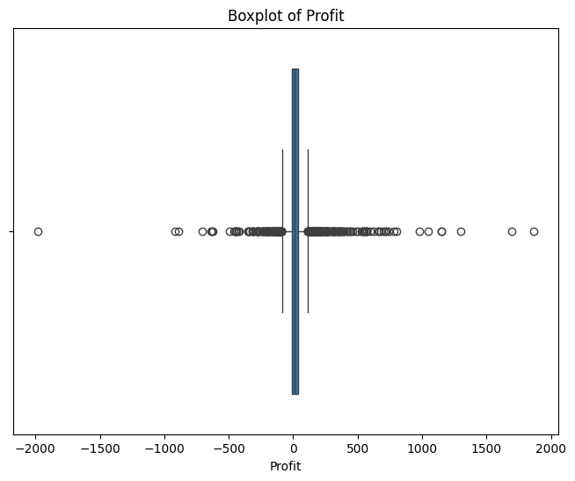
Fig. 2(a) Box plot of ‘Amount’ | Fig. 2(b) Box plot of ‘Profit’

The original data did not require extensive preprocessing due to its high quality. We have checked for missing values & duplicates but the data is void of them. However, from our analysis, Fig 2(a) and Fig. 2(b), we found that ‘Amount’ & ‘Profit’ fields seems to have outliers, but when digged deep we found that the data points belongs to different categories and distributed equally among all categories and came to conclusion that these were the top brands or costliest items of the category and decided not to remove the extreme data points as these were not deviations from data.

From our initial analysis of our dashboard, we’ve wanted average order value to be displayed, so we have derive a new attribute - AOV using existing attributes (Order Amount & Quantity)
- Missing Values: No missing or NaN values were found.
- Duplicates: No duplicate rows were present.
- Derived Columns: Additional columns like Average Order Value (AOV) were created using existing attributes to enhance the analysis.
- Outliers: Observations above the 99th percentile in columns like Amount and Profit were retained to avoid misleading category-specific analysis.

EXPLORATORY DATA ANALYSIS

Leveraging python’s ‘matplotlib’, ‘seaborn’ we performed exploratory data analysis to understand and gain insights about the data. We analysed descriptive statistics, correlations, and categorical comparisons.

Purchase Mode Preferences
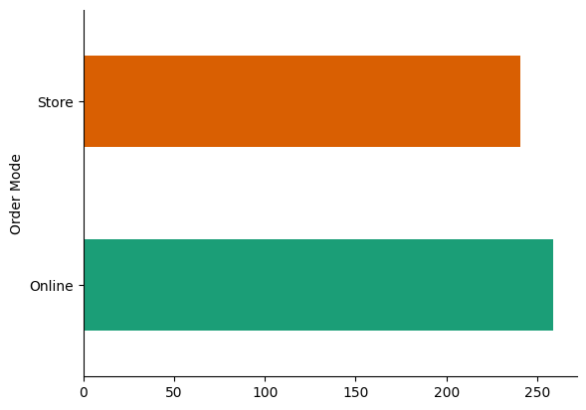 | 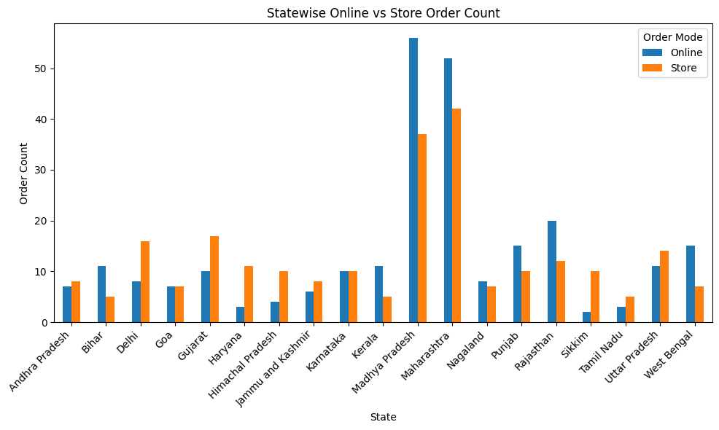
Fig. 3(a) Histogram of Order Mode | Fig. 3(b) Statewise Order Mode

From the above histogram from Fig. 3(a) & Fig. 3(b), Online purchases significantly outnumber in-store purchases indicating a growing preference for e-commerce, especially in states with better telecommunication infrastructure.

Maharashtra and Madhya Pradesh lead in sales revenue. High sales in these regions are linked to their larger populations and stronger online shopping adoption

Category-Level Insights
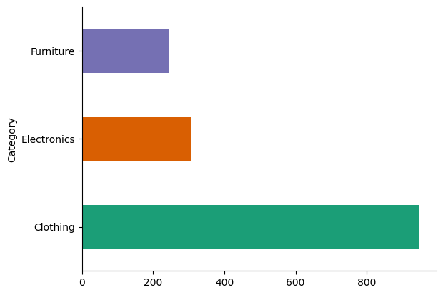 | 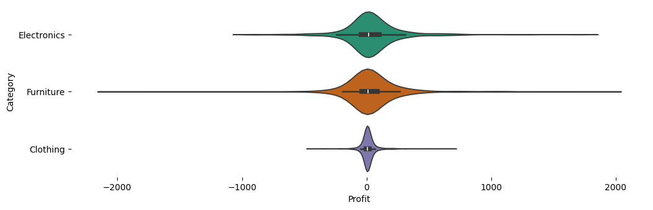
Fig. 4(a) Histogram of Category | Fig. 4(b) Variation of Category’s Profit

From the above plots, Fig. 4(a) & Fig. 4(b), clothing dominates sales volume, followed by electronics. However, Furniture being the least sold category has the highest profit variance, indicating high profitability despite lower sales volume. A takeaway from Fig. 4(b) is that the Furniture category generated higher profits along with significant losses as well, so there is a risk associated with this category.

Payment Mode Analysis

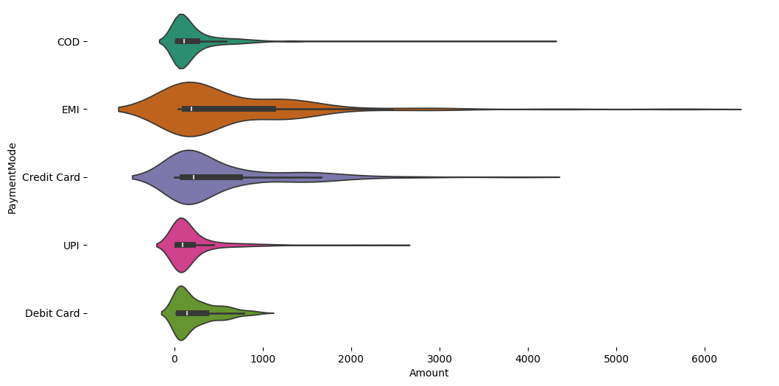 | 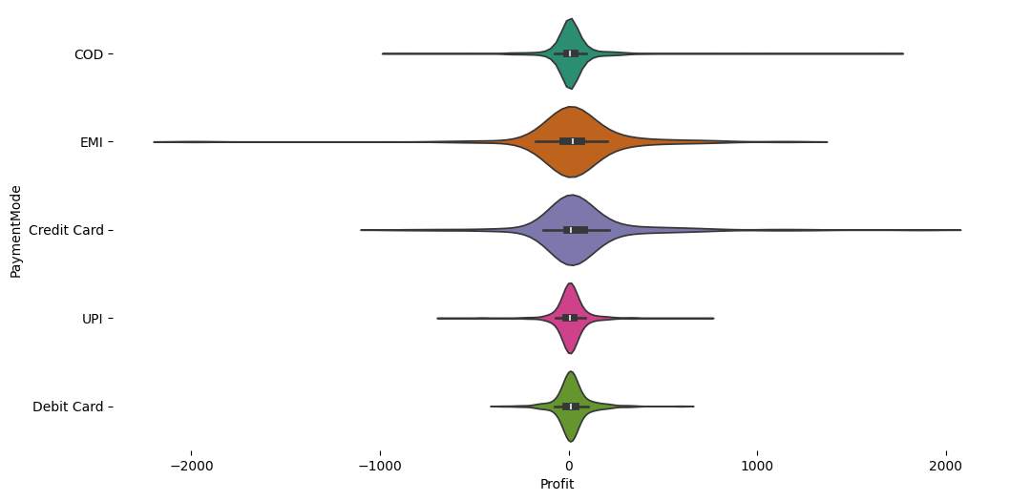
Fig. 5(a) Payment mode with Amount | Fig. 5(b) Payment mode with Profit

From Fig. 5(a) & Fig. 5(b), we can observe that ‘EMI’, ‘Credit card’ modes of payment are generating high revenue and profits. It is evident that EMI and credit card payments are popular for high-value items. These payment methods, while generating high revenue, also show higher loss rates, so businesses have to take significant risk measures when offering these payment modes.

POWER BI DASHBOARD

We loaded the cleaned & preprocessed data to the Power BI desktop and created a dashboard.

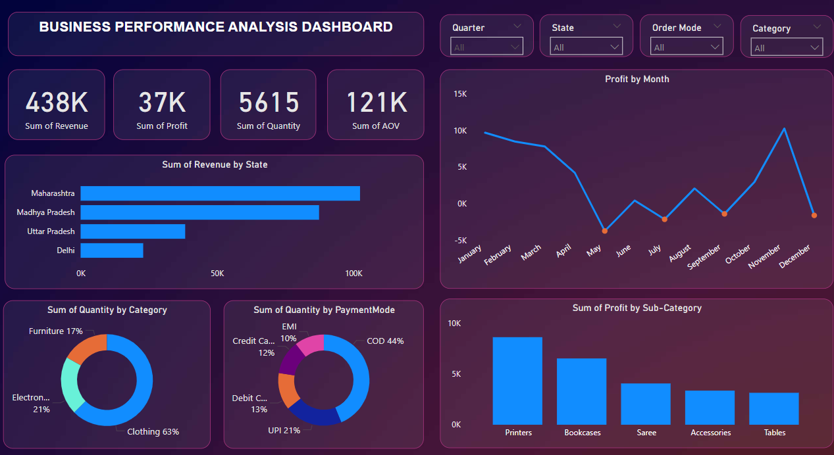
Fig. 6 Power BI Dashboard

On the top-right we provided 4 slicers - ‘Quarter’, ‘State’, ‘Order Mode’ & ‘Category’ allowing the business to apply filters on these 4 attributes. On the visualisation layout, we have Overall metrics - ‘Sum of Revenue’, ‘Sum of Profit’, ‘Sum of Quality’ and ‘Sum of AOV’ showing the respective values for the applied filters.

To let business or stakeholder show the performance in different states, we provided a histogram ‘Sum of Revenue by State’ which shows the revenue generated in the state on the selected filter values. Similarly ‘Sum of Profit by Sub-Category’ to show profit by each sub-category.

In addition to revenue and profit insights, we added the sales of each category - ‘Sum of Quantity by category’, and sales by each payment mode - ‘Sum of Quantity by PaymentMode’ to let business know the trends and insights on each product and payment methods. These 2 plots allow the businesses to manage their inventory and infrastructure effectively.

On the top-right we added a ‘Profit by Month’ line graph, which shows the variation of profit by month. From this plot the stakeholders can observe the trends and business performance across the year and take necessary actions accordingly.

The plots coupled with the 4 slicers, will provide granular insights on the sales, revenue, inventory & customer preferences. This dashboard will help the business to manage their inventory, infrastructure efficiently and can run necessary campaigns based on trends and customer preferences.

FINDINGS & RECOMMENDATIONS

Below are some of the findings & recommendations we can make to the business leveraging the analysis from the dashboard:

Fig. 6 shows that the profits are highest in the month of January & November, lowest in May, July, September & December. And majority of the profits are generated by ‘Printers’, ‘Bookcases’, ‘Saree’ categories. ‘Clothing’ is the highest selling category, ‘COD’ is the preferred mode of payment, Maharashtra & Madhya Pradesh lead the revenue in the country. So, companies should focus more on ‘Maharashtra’ & ‘Madhya Pradesh’ especially in the ‘Clothing’ category allowing ‘COD’ mode of payment to further boost their revenue & profits.

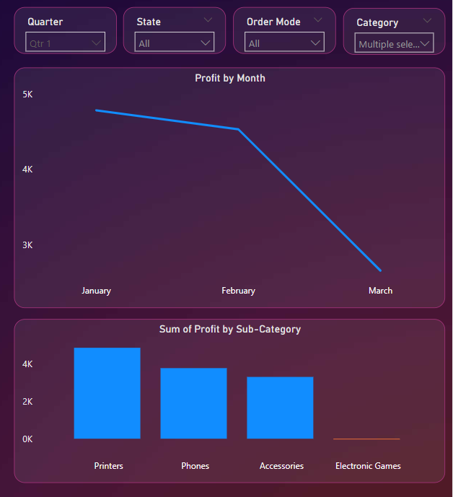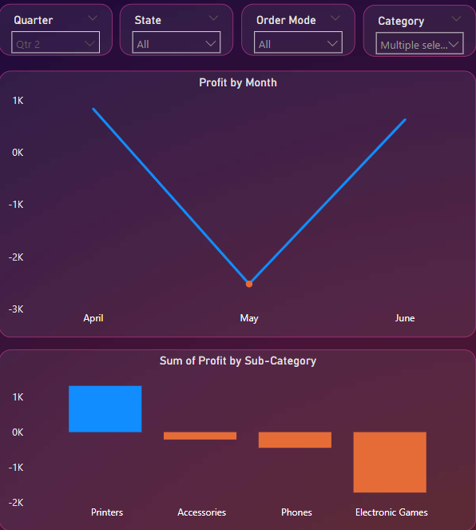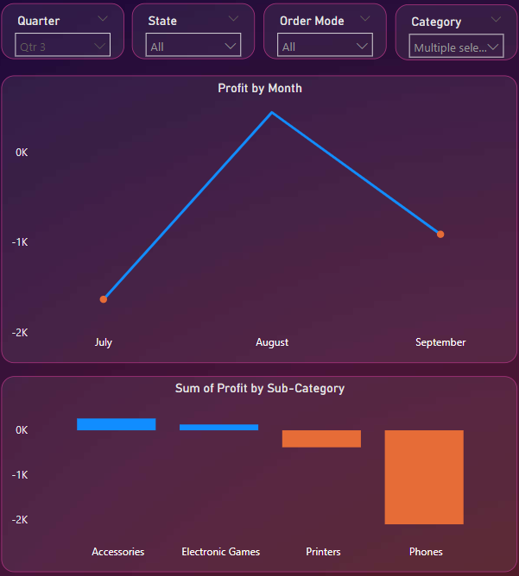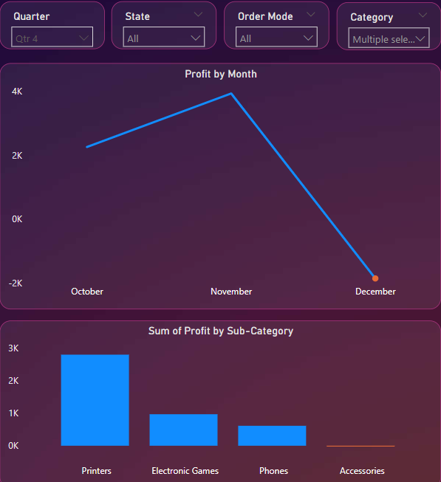
Fig. 7 Profits generated by Electronics in Q1, Q2, Q3, Q4

Businesses can leverage this dashboard to gain insights in all the ways they want. To give an example, we set the category filter to ‘Electronics’ and varied the ‘Quarter’ filter to observe the performance of this category across different quarters.

From the histograms and plots, we can observe that in Q1 & Q4 there are significant profits with negligible losses. However, in Q2, Q3 the ‘Electronics’ are incurring higher losses than profits. And in all the quarters, ‘Printers’ category is the best performing category. So, businesses can make printer supply available across the year in inventory, and should make other items available according to their performance in different quarters. This way businesses can manage the ‘Electronics’ inventory efficiently.

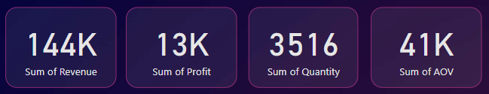
Fig. 8(a) Overall metrics of Clothing category
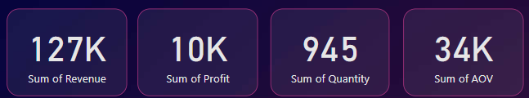
Fig. 8(b) Overall metrics of Furniture category

From Fig. 8(a) & Fig 8(b), ‘Clothing’ category has 3 times higher the sales compared to the ‘Furniture’ category, however if we observe the metrics, ‘Furniture’ category performed more or less similarly to the ‘Clothing’ category in every metric. This can be because of the cost of furniture being highest, the profit obtained is also highest compared to that of the cost of clothes. So, businesses should focus on selling more furniture category items by running targeted campaigns to boost their revenue.

These were summary of our findings & recommendations:
- Customers are preferring ‘Online’ mode of purchase than ‘In-Store’ mode, so business should improve infrastructure for online sales
- ‘Furniture’ items despite having less sales generate huge profits. So business should run campaigns and try selling for more furniture
- Customers prefer to buy costlier items in “EMI” or “Credit Card” mode of payment, and generate high revenue as well. So, businesses should make these options available. And since losses are high for these modes of payment, businesses should take utmost care with these payment modes.
- Business should focus on Maharashtra & Madhya Pradesh, since these two states are generating highest revenues and profits
- Inventory team should make ‘Clothing’ items available for Q1, Q4 as clothing items are sold most in Q1 & Q4
- ‘Electronic games’ are generating losses almost all of the quarters, so business should reduce the supply for this category to reduce losses
- ‘Printers’ are generating profits in all the quarters, so business should make the stock available in all the quarters and locations.

CONCLUSIONS

Throughout this project we as a team effectively addressed the challenge of analyzing multi-branch sales performance variations across channels, leveraging advanced data analytics to derive actionable insights. As described in above methodology we obtained data from a public source, we cleaned (preprocessed) the data, looked for any deviations from actual data and treated them, created new attributes from existing attributes, finally loaded the data into Power BI dashboard. We then added slicers, line plots, histograms to our dashboard to apply filters, show trends and variations respectively. By this we have created a single reusable platform for businesses to view their retail performance, gain insights and manage their inventory, infrastructure effectively, run targeted campaigns, calibrate risks ensuring profits meeting business goals.

Through this project, we learnt key data preprocessing techniques like identifying and handling missing values, deviations from data like outliers, handling numerical values. We understood the importance of Exploratory Data Analysis (EDA) for identifying key performance attributes, and different plotting techniques to get underlying insights from data. We learnt and applied our knowledge on creating Power BI dashboard to our project, and provided insights and recommendations to the business from the dashboard.

In conclusion, this project gave us the opportunity to tackle a real-world business problem while sharpening our skills in data analytics and visualization. By combining technical knowledge with a clear understanding of business needs, we were able to create a solution that helps businesses make smarter decisions, improve their operations, and reach their goals. This experience highlighted the value of data-driven approaches in addressing complex challenges and strengthened our ability to work together as a team to deliver meaningful results.

INDIVIDUAL CONTRIBUTIONS

Sai Lokesh | Data collection, cleaning & manipulation.
Sai Lokesh | Exploratory Data Analysis & descriptive statistics
Sai Lokesh | Dashboard preparation - modifying and finalising dashboard filters & fields
Sai Lokesh | Dashboard analysis & findings
Sai Lokesh | PPT & report preparation
Manikanta M | Exploratory Data Analysis & descriptive statistics
Manikanta M | Dashboard data preparation
Manikanta M | Dashboard theme & layout preparation
Manikanta M | Dashboard analysis & findings
Manikanta M | PPT & report preparation
Nagaraju G | Exploratory Data Analysis & descriptive statistics
Nagaraju G | Dashboard preparation - Addition of different filters, tiles
Nagaraju G | Dashboard analysis & findings
Nagaraju G | Recommendations from findings
Nagaraju G | PPT & Report preparation

REFERENCES

- Chandramana, S. B. (2017). Retail analytics: driving success in retail industry with business analytics.
- Sambrani, M. Sales Dashboard Development for Business Performance Optimization.
- Amar, N., & Baliga, S. Design and Development of Analytical Dashboard.
- Kallel, M. B. E., Bouajaja, S., & Elloumi, A. (2024). Developing a Sales Dashboard with Power BI–A Case Study in a Pharmaceutical Company. Decision Making Advances, 2(1), 142-147.
- Velcu-Laitinen, O., & Yigitbasioglu, O. M. (2012). The Use of Dashboards in Performance Management: Evidence from Sales Managers. International Journal of Digital Accounting Research, 12.
- Bharadwaj, N., Ballings, M., Naik, P. A., Moore, M., & Arat, M. M. (2022). A new livestream retail analytics framework to assess the sales impact of emotional displays. Journal of Marketing, 86(1), 27-47.
- Randhawa, R. S. (2019). Retail Analytics. Essentials of Business Analytics: An Introduction to the Methodology and its Applications, 599-621.

APPENDIX

- Dataset - This link contains the source where we taken the dataset from
- We used ‘Google Collab’ to perform data preprocessing & EDA
- Leveraged ‘Power BI Desktop’ to develop dashboard
- Google Collab - This is the link to code we used to perform EDA & Data analysis
- Dashboard - This is the link to Power BI dashboard

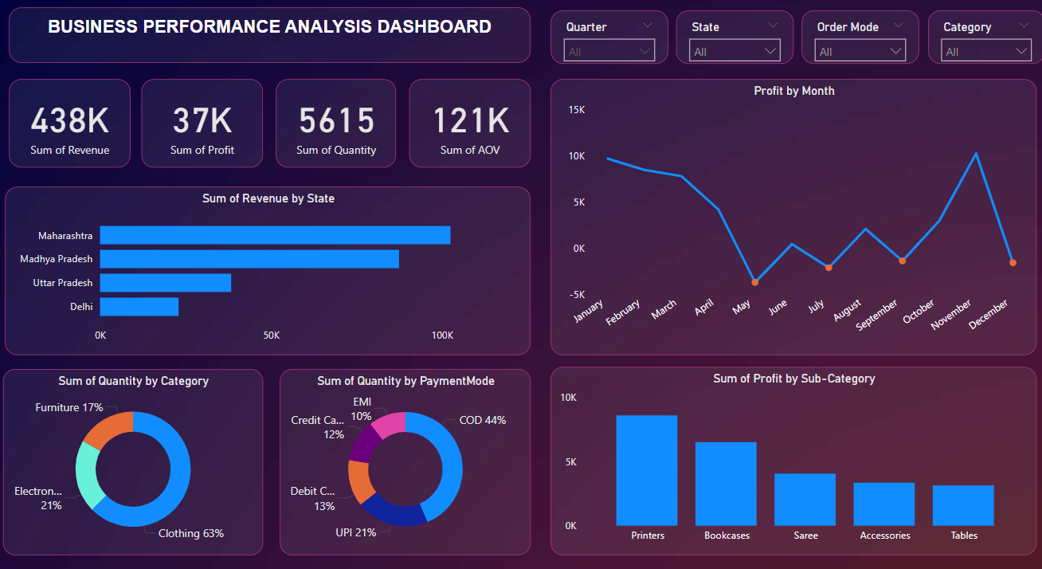
Actual screenshot of the dashboard

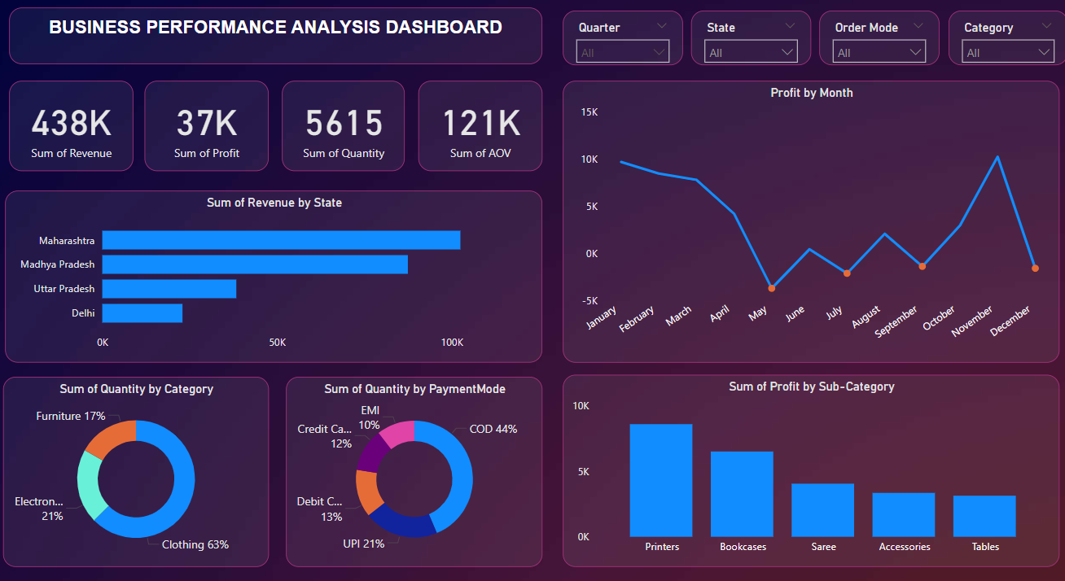
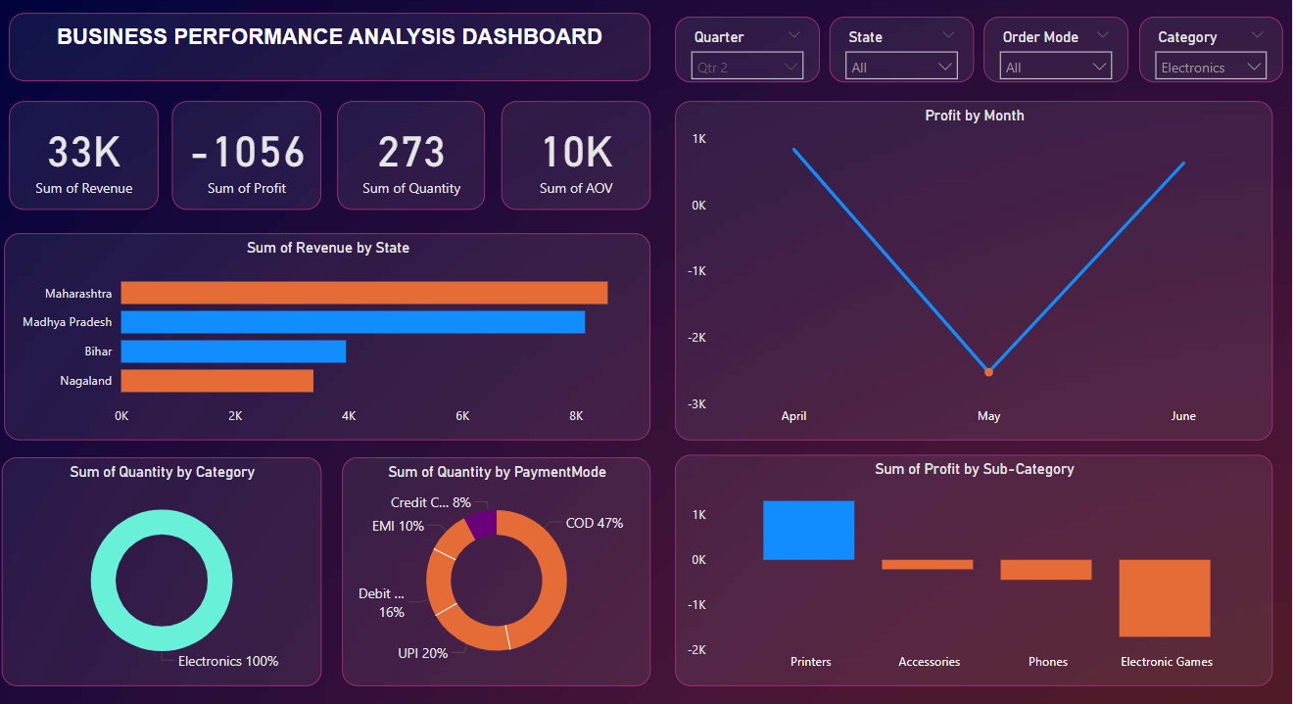
Actual screenshots of ‘Electronic’ category performance in Q1, Q2
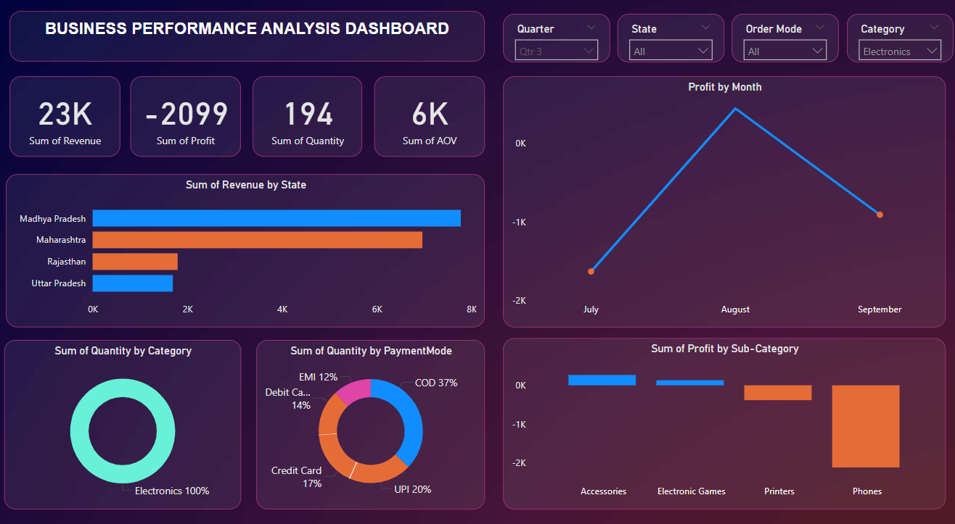
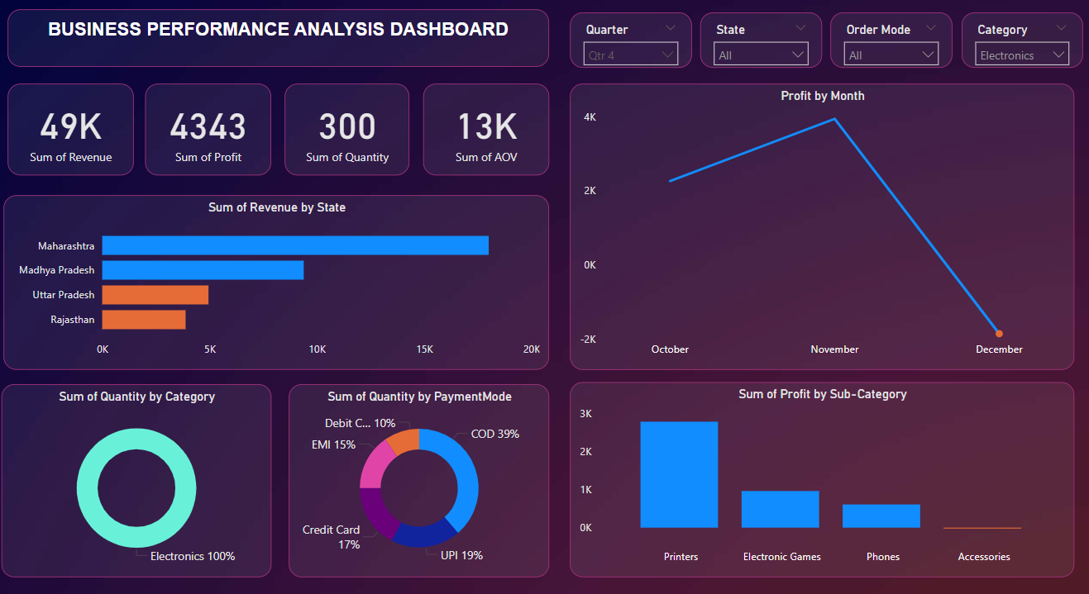
Actual screenshots of ‘Electronic’ category performance in Q3, Q4

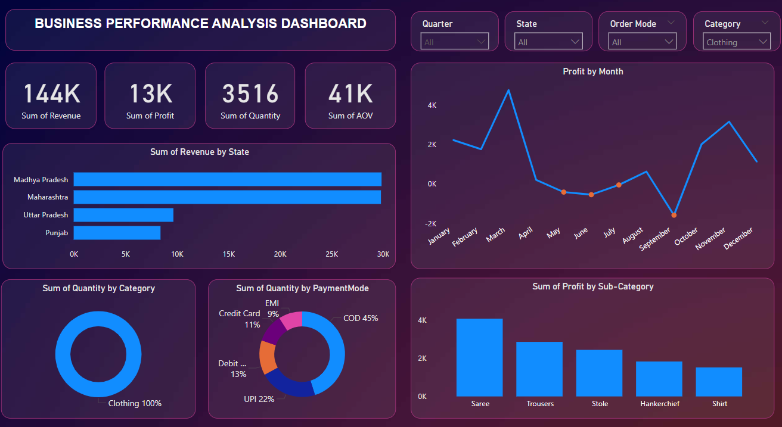
Actual screenshot of ‘Clothing’ category metrics
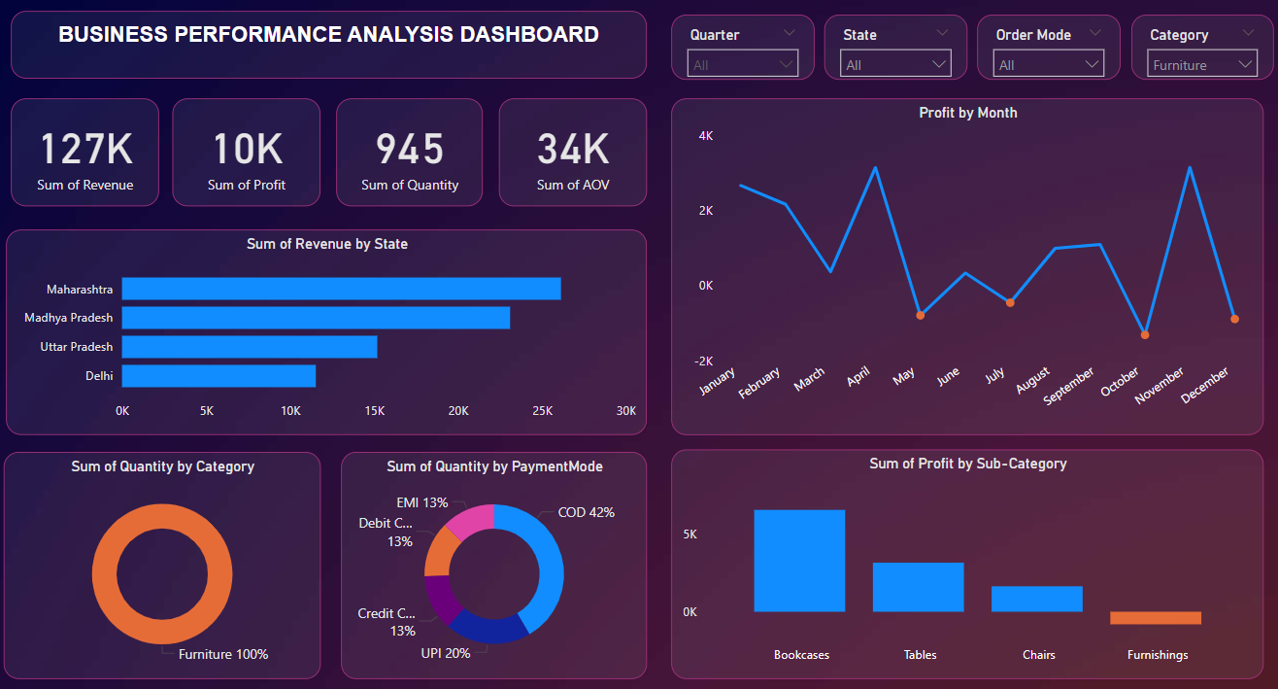
Actual screenshot of ‘Furniture’ category metrics

